A
Major Project
On
Retail Sales Data Warehouse using OLAP
Star schema design, ETL, OLAP analysis and dashboard on PostgreSQL



Submitted By:
Dharmendra Kumar
Domain:
MS SQL

1. Objective and problem statement
A retail business records thousands of transactions every day, but transactional databases are built for fast inserts, not for answering questions like "which products sell best in November?" or "how did each country perform last quarter?". This project designs a data warehouse that stores retail sales in a structure made for analysis and uses OLAP operations to explore it.
Goals:
- Design a star schema for retail sales with clearly defined facts and dimensions.
- Build an ETL pipeline that cleans raw transactions and loads them into PostgreSQL.
- Support roll-up, drill-down, slice and dice operations on a multi-dimensional model.
- Answer business questions with SQL: top-selling products and seasonal trends.
- Present the results in an interactive web dashboard and verify them with automated tests.

2. Requirement analysis

2.1 Facts and dimensions
Type | Details
Fact | Sales transactions. Measures: quantity, unit price, revenue (quantity x unit price).
Dimension: Time | Date, day, month, month name, quarter, year, weekday, weekend flag.
Dimension: Product | Stock code, description, category.
Dimension: Store | Store name (one store per country) and region (Domestic or International).
Dimension: Customer | Customer ID and country.

2.2 Business questions the warehouse answers
- What is the total revenue, and how has it changed by year, quarter and month?
- Which products and categories generate the most revenue?
- Which months show seasonal peaks?
- Which countries and customers contribute most to sales?

2.3 Dataset
The project uses the Kaggle Retail Sales dataset (carrie1/ecommerce-data), which contains invoice number, stock code, description, quantity, invoice date, unit price, customer ID and country. A generator script creates a sample file with the same columns so the project can also run without the download.

2.4 Tools used
Layer | Tool
Database | PostgreSQL (pgAdmin 4 for administration)
ETL | Python with Pandas and SQLAlchemy
OLAP | PostgreSQL ROLLUP, CUBE and window functions
Backend | Python Flask REST API
Frontend | HTML, CSS, JavaScript, Chart.js
IDE and testing | PyCharm, pytest

3. Data warehouse design
A star schema was chosen because the dimensions are small and flat, which keeps queries to a single join level and makes aggregation fast. The central fact table references four-dimension tables through surrogate keys.
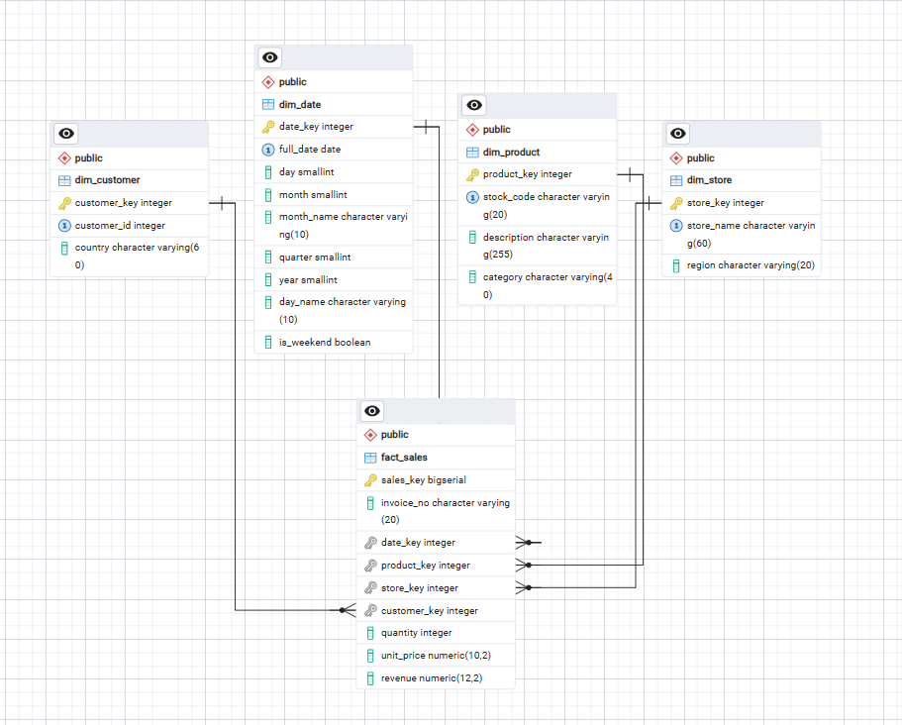
Figure: Star schema ERD

3.1 Tables
Table | Columns
fact_sales | sales_key (PK), invoice_no, date_key, product_key, store_key, customer_key, quantity, unit_price, revenue
dim_date | date_key (PK, yyyymmdd), full_date, day, month, month_name, quarter, year, day_name, is_weekend
dim_product | product_key (PK), stock_code, description, category
dim_store | store_key (PK), store_name, region
dim_customer | customer_key (PK), customer_id, country

3.2 Design decisions
- Integrity: Foreign keys on the fact table guarantee that every sale links to a valid dimension row.
- Validation: CHECK constraints require quantity and unit price to be positive.
- Performance: Indexes on all four foreign keys speed up joins and group-by queries.
- Category: Product category is derived from keywords in the product description, because the source data has no category field.
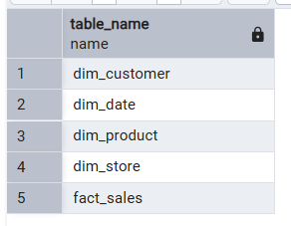
Figure: Tables created in pgAdmin

4. ETL process
The ETL script (etl/etl.py) runs in three stages.

4.1 Extract
The CSV file is read with Pandas using ISO-8859-1 encoding. If no file exists, the generator creates a sample dataset with the same columns.

4.2 Transform
- Remove rows with missing customer ID or description.
- Remove cancelled invoices (invoice numbers starting with C).
- Remove rows with zero or negative quantity or price and drop duplicates.
- Standardise stock codes and descriptions (trim, upper case).
- Calculate revenue as quantity x unit price.
- Build the date dimension for every day in the data range, and assign surrogate keys to products, stores and customers.
- Merge the cleaned data with the dimensions to produce the fact table.

4.3 Load
The script runs schema.sql to recreate the tables, then bulk-inserts the dimensions first and the fact table last, inside one transaction. If anything fails, nothing is committed.
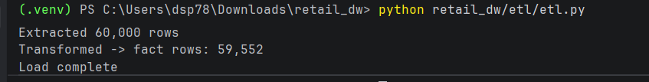
Figure: ETL output in PyCharm terminal showing 'Load complete'
Table | Rows loaded
fact_sales | [59552]
dim_product | [160]
dim_customer | [1500]
dim_store | [7]
dim_date | [374]

5. OLAP cubes and operations
The multi-dimensional cube is formed by the fact measures (revenue, units, orders) along the time, product, store and customer dimensions. PostgreSQL's ROLLUP and CUBE produce the subtotals, and the Flask API exposes them to the dashboard.

5.1 Operations implemented
Operation | Meaning | Implementation
Aggregation | Sum measures at a chosen grain | SUM(revenue) with GROUP BY
Roll-up | Move to a coarser level with subtotals | GROUP BY ROLLUP(year, quarter, month)
Drill-down | Move to a finer level | Click a row: year, then quarter, then month
Slice | Fix one dimension to one value | Filter: year = 2011
Dice | Fix several dimensions or values | Filter: year, category and country together
Cube | All combinations of dimensions | GROUP BY CUBE(year, category, store)

5.2 Example: roll-up query
SELECT d.year, d.quarter, d.month, SUM(f.revenue) AS revenue
FROM fact_sales f JOIN dim_date d ON d.date_key = f.date_key
GROUP BY ROLLUP (d.year, d.quarter, d.month)
ORDER BY d.year, d.quarter, d.month;
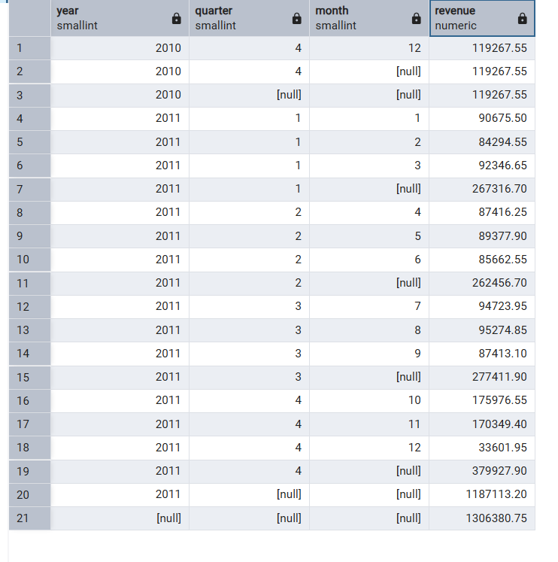
Figure: Roll-up query result in pgAdmin
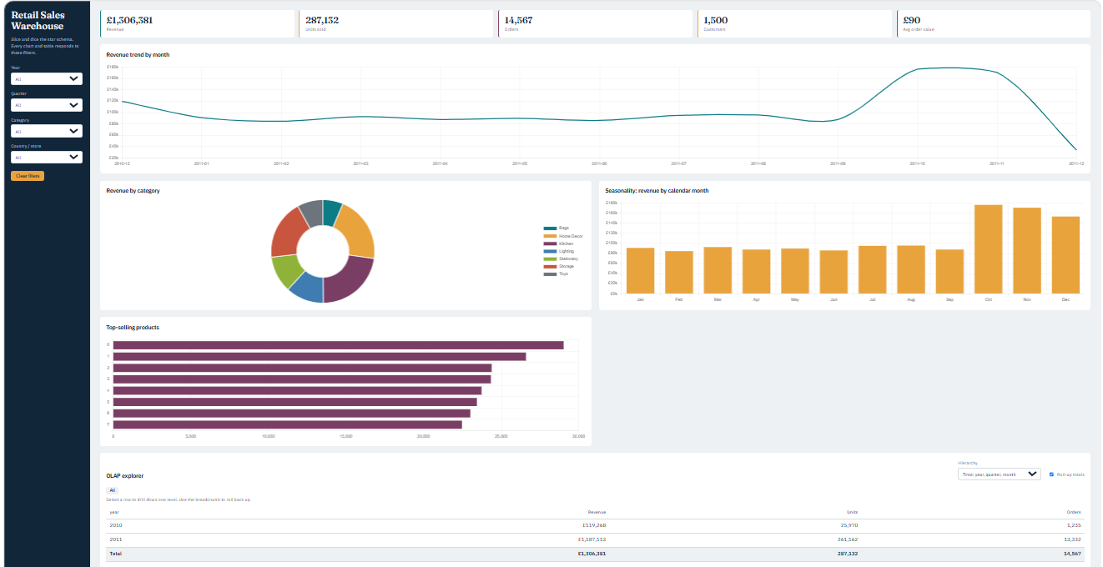
Figure: Dashboard OLAP explorer with roll-up totals enabled
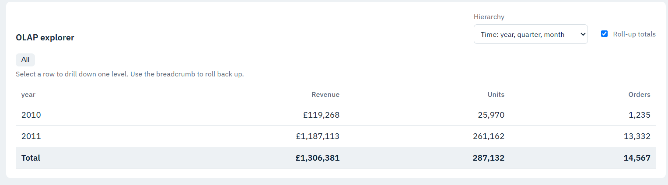
Figure: Drill-down from year to quarter to month
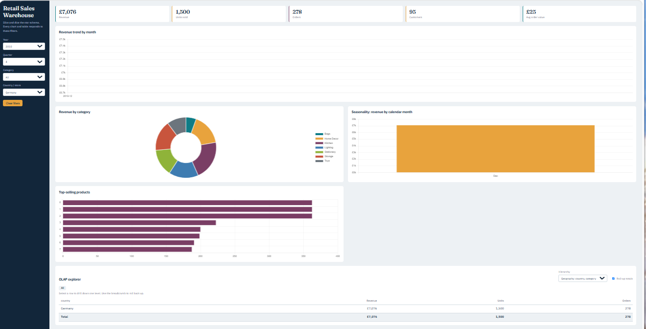
Figure: Slice and dice using sidebar filters

6. Business insights with SQL

6.1 Top-selling products
SELECT p.description, SUM(f.quantity) AS units, SUM(f.revenue) AS revenue
FROM fact_sales f JOIN dim_product p ON p.product_key = f.product_key
GROUP BY p.description ORDER BY revenue DESC LIMIT 10;
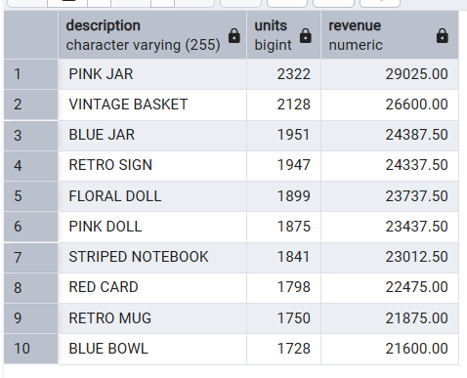
Figure: Top 10 products query result
Observation: [Write 2-3 lines: which products lead, and which category they belong to.]

6.2 Seasonal trends and month-over-month growth
WITH m AS (SELECT d.year, d.month, SUM(f.revenue) AS revenue
FROM fact_sales f JOIN dim_date d ON d.date_key = f.date_key GROUP BY d.year, d.month)
SELECT year, month, revenue,
ROUND(100*(revenue - LAG(revenue) OVER (ORDER BY year, month))
/ NULLIF(LAG(revenue) OVER (ORDER BY year, month), 0), 1) AS mom_growth_pct
FROM m ORDER BY year, month;
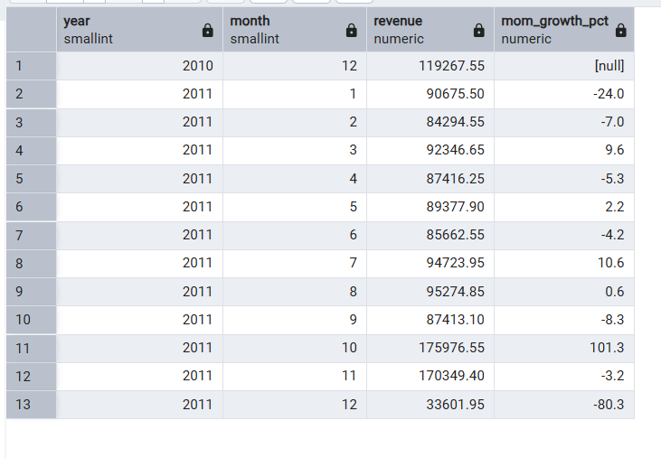
Figure: Seasonal trend query result
Observation: [Write 2-3 lines: which months peak (for example October and November) and the likely reason.]

6.3 Other insights
- Revenue by category, country and top customers are available in the dashboard and through the API.

7. Visualisation and dashboard
The web dashboard is served by Flask at http://127.0.0.1:5000. It contains KPI cards (revenue, units, orders, customers, average order value), a monthly revenue trend, revenue by category, seasonality by calendar month, top products, an OLAP explorer with drill-down, and a top customers table. The sidebar filters apply to every element at once.
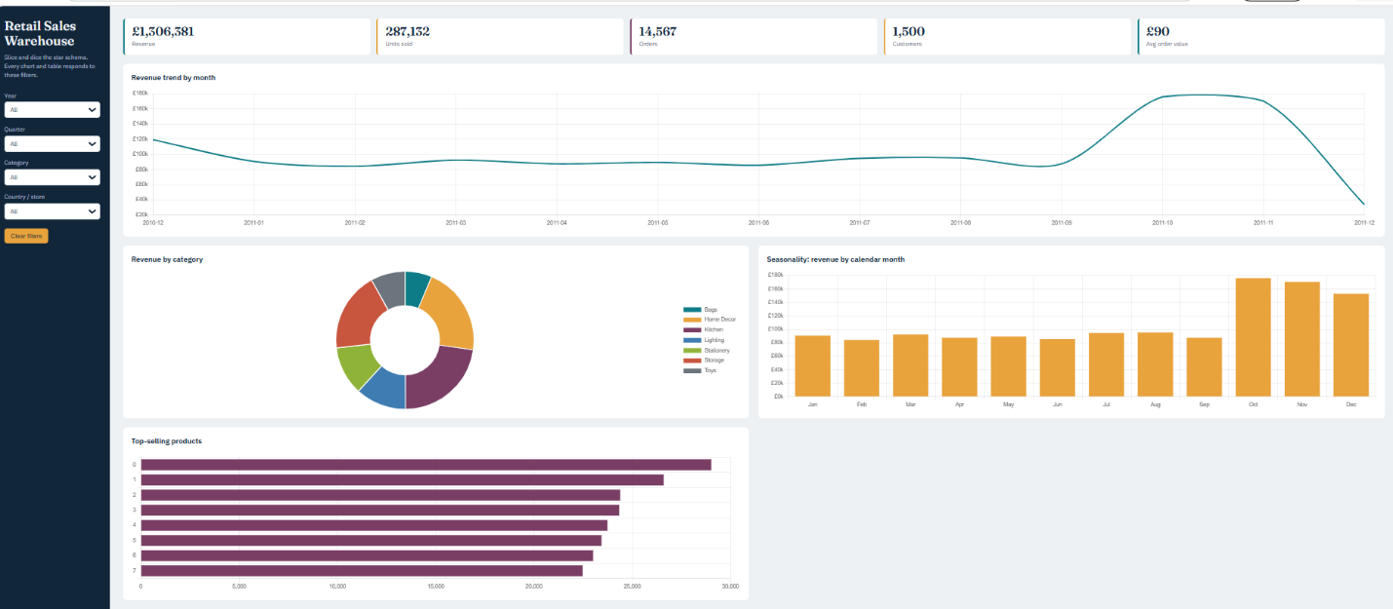
Figure: Full dashboard (all filters cleared)
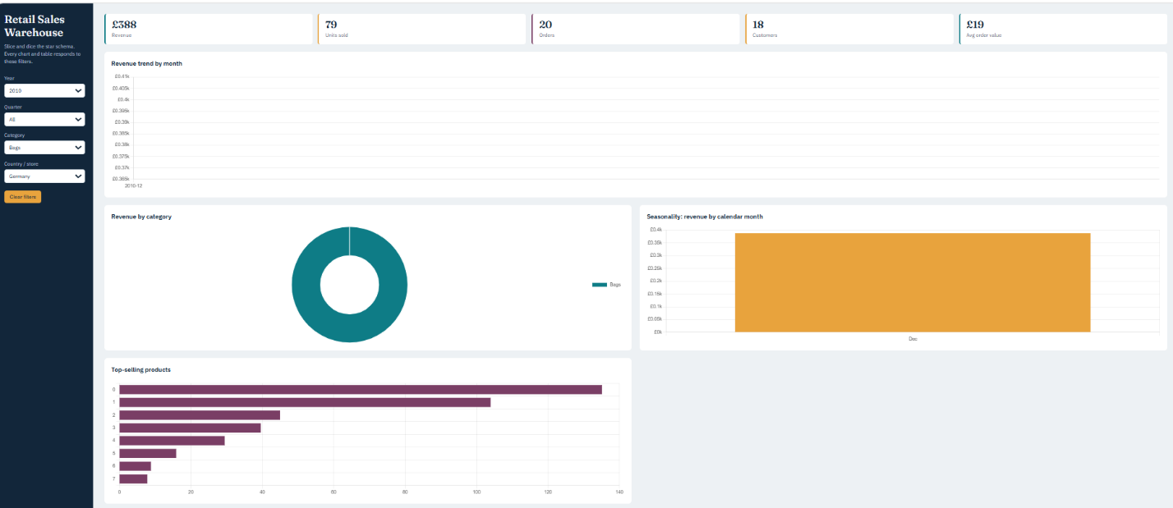
Figure: Dashboard with filters applied (slice or dice)

7.1 REST API
Endpoint | Purpose
/api/filters | Values for the filter drop-downs
/api/kpis | Headline numbers
/api/olap?group=year,quarter&rollup=1 | Aggregation, roll-up, drill-down
/api/top-products | Top-selling products
/api/seasonal | Revenue by calendar month
/api/top-customers | Highest-revenue customers

All endpoints accept year, quarter, month, category and country filters. Values are passed as bound query parameters, which prevents SQL injection.

8. Testing
Automated tests (tests/test_warehouse.py) run with pytest against the loaded database.
Test | What it checks | Result
Tables not empty | All five tables contain rows | [Pass]
No orphan foreign keys | Every fact row matches all four dimensions | [Pass]
Revenue accuracy | revenue = quantity x unit price on every row | [Pass]
Roll-up grand total | ROLLUP total equals the sum of the fact table | [Pass]
Query performance | A CUBE aggregation finishes in under 2 seconds | [Pass]

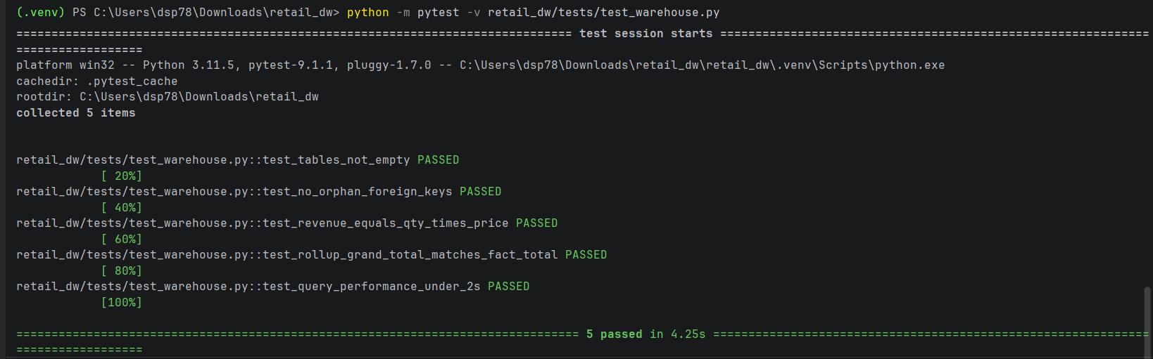
Figure: pytest -v output showing all tests passed

9. Conclusion and future scope
The project delivers a working retail data warehouse: a star schema in PostgreSQL, a repeatable ETL pipeline, OLAP operations (aggregation, roll-up, drill-down, slice, dice, cube), SQL insights on top products and seasonality, an interactive dashboard, and automated tests that verify integrity and accuracy.
Future scope:
- Move to a snowflake schema with a separate category table, or add a real store dimension.
- Schedule the ETL for incremental daily loads.
- Add materialized views or partitioning for much larger datasets.
- Connect Power BI or Tableau to the same PostgreSQL database.
- Add user login and role-based access to the dashboard.

References
- Kaggle: https://www.kaggle.com/datasets/carrie1/ecommerce-data
- Kaggle: https://www.kaggle.com/datasets/kyanyoga/sample-sales-data
- PostgreSQL documentation: GROUPING SETS, CUBE and ROLLUP
- Project source code: [your GitHub repository link]

